

Foundations of Programming

Assignment No. : 06
PROBLEM STATEMENT:Write a C function to compute the factorial of a number with and without recursion.

OBJECTIVE:

To demonstrate two different approaches for calculating the factorial of a number: iterative (non-recursive) and recursive, showcasing the versatility of problem-solving methods in programming.

THEORY:
- Explain the difference between the iterative and recursive approaches to calculating the factorial of a number.
- What is the base case in the recursive function for computing factorials, and why is it necessary?
- How does the program handle invalid input, such as negative numbers, and why is this important?
Algorithm :

Algorithm 1: Factorial Using Iteration (Non-Recursive Method)
Step 1: Start
Step 2: Read the number n
Step 3: If n < 0, display “Invalid Input” and stop
Step 4: Initialize fact = 1
Step 5: Set i = 1
Step 6: Repeat while i ≤ n
• fact = fact × i
• i = i + 1
Step 7: Display the value of fact
Step 8: Stop

Algorithm 2: Factorial Using Recursion
Step 1: Start
Step 2: Read the number n
Step 3: If n < 0, display “Invalid Input” and stop
Step 4: Call the function fact_recursive(n)
Step 5: Inside the recursive function:
• If n == 0, return 1
• Else return n × fact_recursive(n − 1)
Step 6: Display the returned value
Step 7: Stop

FLOWCHART :
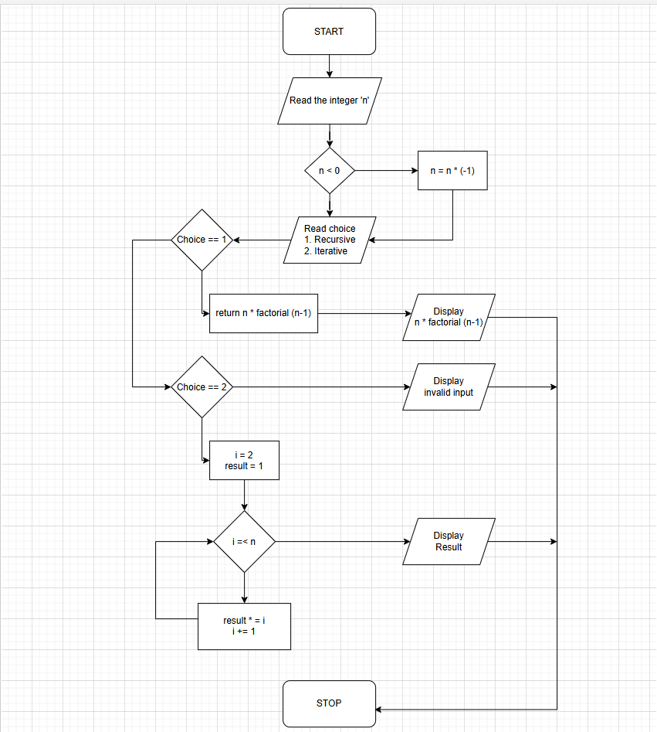

PLATFORM: C Compiler
Code : 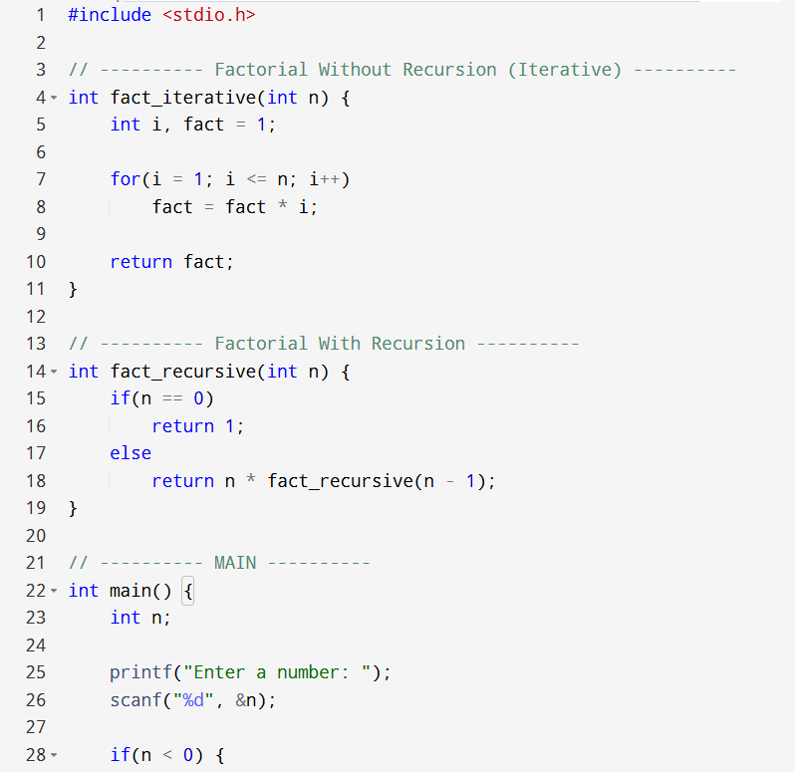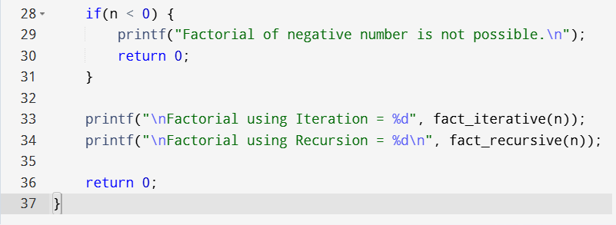

INPUT:
OUTPUT:
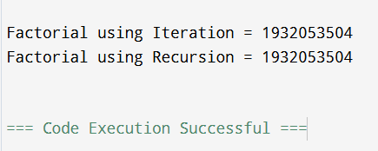
CONCLUSION: Thus, we have successfully executed factorial of a number with and without recursion.

FAQs:
1. What is the purpose of calculating factorial in programming?
2. What is the difference between recursive and non-recursive (iterative) methods?

